sklearn
Taken from: https://scikit-learn.org/stable/getting_started.html
Scikit-learn is an open-source machine learning library that supports supervised and unsupervised learning. It also provides various tools for model fitting, data preprocessing, model selection, model evaluation, and many other utilities.
Key features and available algorithms
Scikit-learn provides dozens of built-in machine learning algorithms and models, called estimators. Each estimator can be fitted to some data using its fit method.
Fitting and predicting: estimator basics
Scikit-learn provides dozens of built-in machine learning algorithms and models, called estimators. Each estimator can be fitted to some data using its fit method.
Here is a simple example where we fit a RandomForestClassifier to some very basic data:
from sklearn.ensemble import RandomForestClassifier
clf = RandomForestClassifier(random_state=0)
X = [[ 1, 2, 3], # 2 samples, 3 features
[11, 12, 13]]
y = [0, 1] # classes of each sample
clf.fit(X, y)
RandomForestClassifier(random_state=0)
The fit method generally accepts 2 inputs:
- The samples matrix (or design matrix) X. The size of X is typically (n_samples, n_features), which means that samples are represented as rows and features are represented as columns.
- The target values y which are real numbers for regression tasks, or integers for classification (or any other discrete set of values). For unsupervised learning tasks, y does not need to be specified. y is usually a 1d array where the i th entry corresponds to the target of the i th sample (row) of X.
Both X and y are usually expected to be numpy arrays or equivalent array-like data types, though some estimators work with other formats such as sparse matrices.
Once the estimator is fitted, it can be used for predicting target values of new data. You don’t need to re-train the estimator:
clf.predict(X) # predict classes of the training data
array([0, 1])
clf.predict([[4, 5, 6], [14, 15, 16]]) # predict classes of new data
array([0, 1])
Transformers and pre-processors
Machine learning workflows are often composed of different parts. A typical pipeline consists of a pre-processing step that transforms or imputes the data, and a final predictor that predicts target values.
In scikit-learn, pre-processors and transformers follow the same API as the estimator objects (they actually all inherit from the same BaseEstimator class). The transformer objects don’t have a predict method but rather a transform method that outputs a newly transformed sample matrix X:
from sklearn.preprocessing import StandardScaler
X = [[0, 15],
[1, -10]]
# scale data according to computed scaling values
StandardScaler().fit(X).transform(X)
array([[-1., 1.],
[ 1., -1.]])
Sometimes, you want to apply different transformations to different features: the ColumnTransformer is designed for these use-cases.
Pipelines: chaining pre-processors and estimators
Transformers and estimators (predictors) can be combined together into a single unifying object: a Pipeline. The pipeline offers the same API as a regular estimator: it can be fitted and used for prediction with fit and predict. As we will see later, using a pipeline will also prevent you from data leakage, i.e. disclosing some testing data in your training data.
In the following example, we load the Iris dataset, split it into train and test sets, and compute the accuracy score of a pipeline on the test data:
from sklearn.preprocessing import StandardScaler
from sklearn.linear_model import LogisticRegression
from sklearn.pipeline import make_pipeline
from sklearn.datasets import load_iris
from sklearn.model_selection import train_test_split
from sklearn.metrics import accuracy_score

# create a pipeline object
pipe = make_pipeline(
StandardScaler(),
LogisticRegression()
)

# load the iris dataset and split it into train and test sets
X, y = load_iris(return_X_y=True)
X_train, X_test, y_train, y_test = train_test_split(X, y, random_state=0)

# fit the whole pipeline
pipe.fit(X_train, y_train)
Pipeline(steps=[('standardscaler', StandardScaler()),
('logisticregression', LogisticRegression())])
# we can now use it like any other estimator
accuracy_score(pipe.predict(X_test), y_test)
0.97...
Model evaluation
Fitting a model to some data does not entail that it will predict well on unseen data. This needs to be directly evaluated. We have just seen the train_test_split helper that splits a dataset into train and test sets, but scikit-learn provides many other tools for model evaluation, in particular for cross-validation.
We here briefly show how to perform a 5-fold cross-validation procedure, using the cross_validate helper. Note that it is also possible to manually iterate over the folds, use different data splitting strategies, and use custom scoring functions. Please refer to our User Guide for more details:
from sklearn.datasets import make_regression
from sklearn.linear_model import LinearRegression
from sklearn.model_selection import cross_validate

X, y = make_regression(n_samples=1000, random_state=0)
lr = LinearRegression()

result = cross_validate(lr, X, y) # defaults to 5-fold CV
result['test_score'] # r_squared score is high because dataset is easy
array([1., 1., 1., 1., 1.])
Automatic parameter searches
All estimators have parameters (often called hyper-parameters in the literature) that can be tuned. The generalization power of an estimator often critically depends on a few parameters. For example a RandomForestRegressor has a n_estimators parameter that determines the number of trees in the forest, and a max_depth parameter that determines the maximum depth of each tree. Quite often, it is not clear what the exact values of these parameters should be since they depend on the data at hand.
Scikit-learn provides tools to automatically find the best parameter combinations (via cross-validation). In the following example, we randomly search over the parameter space of a random forest with a RandomizedSearchCV object. When the search is over, the RandomizedSearchCV behaves as a RandomForestRegressor that has been fitted with the best set of parameters. Read more in the User Guide:
from sklearn.datasets import make_regression
from sklearn.ensemble import RandomForestRegressor
from sklearn.model_selection import RandomizedSearchCV
from sklearn.model_selection import train_test_split
from scipy.stats import randint

# create a synthetic dataset
X, y = make_regression(n_samples=20640,
n_features=8,
noise=0.1,
random_state=0)
X_train, X_test, y_train, y_test = train_test_split(X, y, random_state=0)

# define the parameter space that will be searched over
param_distributions = {'n_estimators': randint(1, 5),
'max_depth': randint(5, 10)}

# now create a searchCV object and fit it to the data
search = RandomizedSearchCV(estimator=RandomForestRegressor(random_state=0),
n_iter=5,
param_distributions=param_distributions,
random_state=0)
search.fit(X_train, y_train)
RandomizedSearchCV(estimator=RandomForestRegressor(random_state=0), n_iter=5,
param_distributions={'max_depth': ...,
'n_estimators': ...},
random_state=0)
search.best_params_
{'max_depth': 9, 'n_estimators': 4}

# the search object now acts like a normal random forest estimator
# with max_depth=9 and n_estimators=4
search.score(X_test, y_test)
0.84...
Note
In practice, you almost always want to search over a pipeline, instead of a single estimator. One of the main reasons is that if you apply a pre-processing step to the whole dataset without using a pipeline, and then perform any kind of cross-validation, you would be breaking the fundamental assumption of independence between training and testing data. Indeed, since you pre-processed the data using the whole dataset, some information about the test sets are available to the train sets. This will lead to over-estimating the generalization power of the estimator (you can read more in this Kaggle post).
Using a pipeline for cross-validation and searching will largely keep you from this common pitfall.

Supervised Learning
Ordinary Least Squares
Taken from: https://scikit-learn.org/stable/modules/linear_model.html
LinearRegression fits a linear model with coefficients w = (w_1, ..., w_p) to minimize the residual sum of squares between the observed targets in the dataset, and the targets predicted by the linear approximation. Mathematically it solves a problem of the form:
$$\min_{w}||Xw-y||_{2}^{2}$$
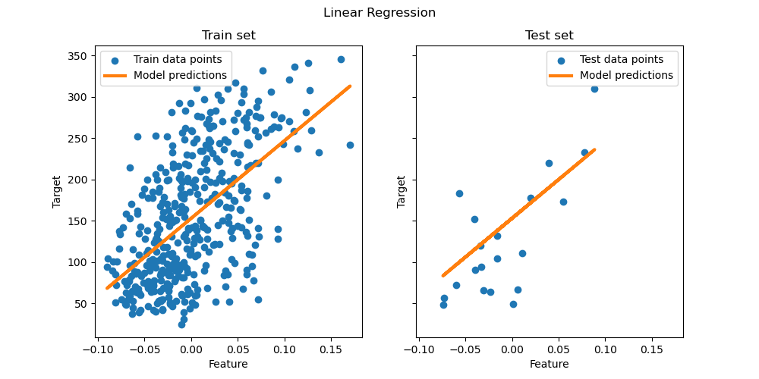

LinearRegression takes in its fit method arguments X, y, sample_weight and stores the coefficients of the linear model in its coef_ and intercept_ attributes:
from sklearn import linear_model
reg = linear_model.LinearRegression()
reg.fit([[0, 0], [1, 1], [2, 2]], [0, 1, 2])
reg.coef_
reg.intercept_
The coefficient estimates for Ordinary Least Squares rely on the independence of the features. When features are correlated and some columns of the design matrix $X$ have an approximately linear dependence, the design matrix becomes close to singular and as a result, the least-squares estimate becomes highly sensitive to random errors in the observed target, producing a large variance. This situation of multicollinearity can arise, for example, when data are collected without an experimental design.

Unsupervised Learning
K-means Clustering
Taken from: https://scikit-learn.org/stable/modules/clustering.html#k-means
The KMeans algorithm clusters data by trying to separate samples in n groups of equal variance, minimizing a criterion known as the inertia or within-cluster sum-of-squares (see below). This algorithm requires the number of clusters to be specified. It scales well to large numbers of samples and has been used across a large range of application areas in many different fields.
The k-means algorithm divides a set of $N$ samples $X$ into $K$ disjoint clusters $C$, each described by the mean $μ_{j}$ of the samples in the cluster. The means are commonly called the cluster “centroids”; note that they are not, in general, points from $X$, although they live in the same space.
The K-means algorithm aims to choose centroids that minimise the inertia, or within-cluster sum-of-squares criterion:
$$\sum_{i=0}^{n}{\min_{μ_{j}∈C}}(||x_{i}-μ_{j}||^{2})$$
Inertia can be recognized as a measure of how internally coherent clusters are. It suffers from various drawbacks:
- Inertia makes the assumption that clusters are convex and isotropic, which is not always the case. It responds poorly to elongated clusters, or manifolds with irregular shapes.
- Inertia is not a normalized metric: we just know that lower values are better and zero is optimal. But in very high-dimensional spaces, Euclidean distances tend to become inflated (this is an instance of the so-called “curse of dimensionality”). Running a dimensionality reduction algorithm such as Principal component analysis (PCA) prior to k-means clustering can alleviate this problem and speed up the computations.
K-means is often referred to as Lloyd’s algorithm. In basic terms, the algorithm has three steps. The first step chooses the initial centroids, with the most basic method being to choose $k$ samples from the dataset $X$. After initialization, K-means consists of looping between the two other steps. The first step assigns each sample to its nearest centroid. The second step creates new centroids by taking the mean value of all of the samples assigned to each previous centroid. The difference between the old and the new centroids are computed and the algorithm repeats these last two steps until this value is less than a threshold. In other words, it repeats until the centroids do not move significantly.
K-means is equivalent to the expectation-maximization algorithm with a small, all-equal, diagonal covariance matrix.
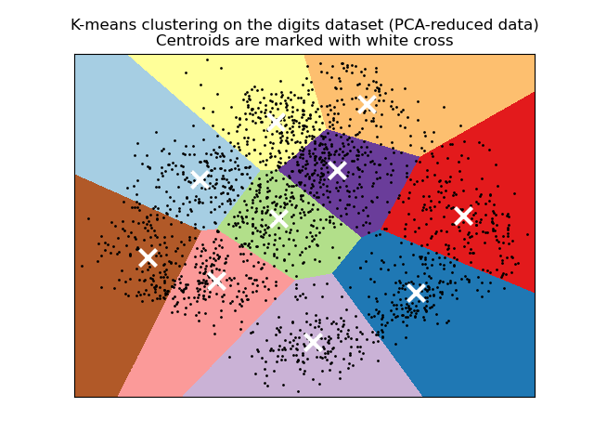
The algorithm can also be understood through the concept of Voronoi diagrams. First the Voronoi diagram of the points is calculated using the current centroids. Each segment in the Voronoi diagram becomes a separate cluster. Secondly, the centroids are updated to the mean of each segment. The algorithm then repeats this until a stopping criterion is fulfilled. Usually, the algorithm stops when the relative decrease in the objective function between iterations is less than the given tolerance value. This is not the case in this implementation: iteration stops when centroids move less than the tolerance.
Given enough time, K-means will always converge, however this may be to a local minimum. This is highly dependent on the initialization of the centroids. As a result, the computation is often done several times, with different initializations of the centroids. One method to help address this issue is the k-means++ initialization scheme, which has been implemented in scikit-learn (use the init='k-means++' parameter). This initializes the centroids to be (generally) distant from each other, leading to probably better results than random initialization, as shown in the reference.
The algorithm supports sample weights, which can be given by a parameter sample_weight. This allows to assign more weight to some samples when computing cluster centers and values of inertia. For example, assigning a weight of 2 to a sample is equivalent to adding a duplicate of that sample to the dataset $X$.

